Лабораторные Работы
Копейкин Сергей ZIS-224
- График Функции
set terminal png size 400,300 enhanced font "Helvetica,20"
set output 'output.png'
set title "Parabola"
set xlabel "X"
set ylabel "Y"
plot [-30:30] [0:300] x**2+4*x with lp 1

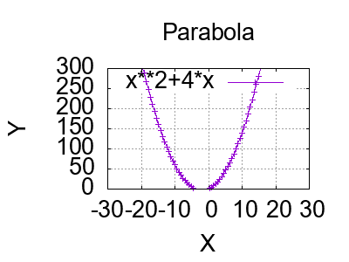
- График параметрической функции
set term png
set output "labs1.png"
set title "Parametric Kopeykin Sergey ZIS-224"
set xlabel "X"
set ylabel "Y"
set parametric
f(t) =sin(t)/1
set label "LABS1" at 0,-4
plot cos(f(t)), t
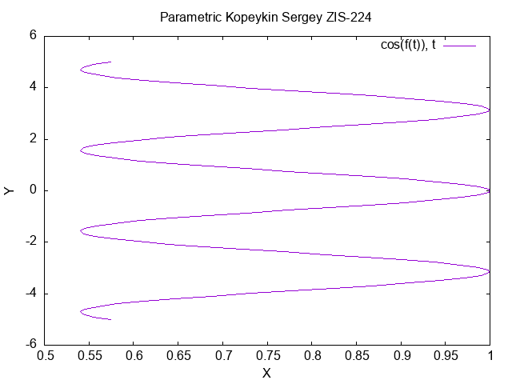

- График трехмерной функции

set term png
set output "labs3.png"
set label "LABS3" at 10,12
set isosample 2,2
splot cos(y)* 3sin(x)

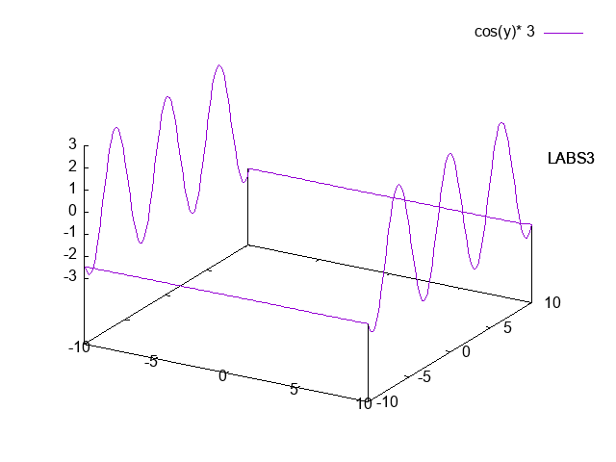

- График трехмерной параметрической функции

set term png
set output "labs4.png"
set label "LABS4" at 1,-15
set parametric
f(u,v) = sin(u) * 3cos(v)
set isosample 10,10
set hidden3d
splot cos(f(u,v)), u, v

