Агафонова Анна отчет по системам трехмерной визуализации
1. Декартовые координаты
set output 'cerves.png'
set title "Curves"
set key left box
set samples 50
set style data points
plot [-10:10] sin(x),cos(atan(x))

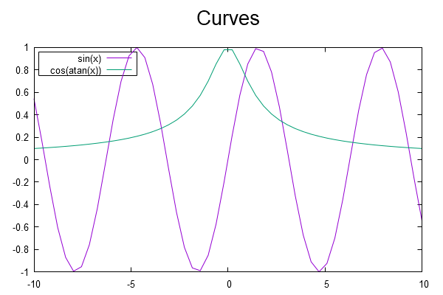

2. Параметрическая кривая
set output 'spiral.png'
set title "Spiral"
set dummy t, y
set key bmargin center horizontal Right noreverse enhanced autotitle box lt black linewidth 1.000 dashtype solid
set parametric
set samples 160, 160
set style data lines
set trange [ 0.000100000 : 31.4159 ] noreverse nowriteback
set xrange [ * : * ] noreverse writeback
set x2range [ * : * ] noreverse writeback
set yrange [ -1.50000 : 1.50000 ] noreverse writeback
set y2range [ * : * ] noreverse writeback
set zrange [ * : * ] noreverse writeback
set cbrange [ * : * ] noreverse writeback
set rrange [ * : * ] noreverse writeback
NO_ANIMATION = 1
plot sin(t)/t,cos(t)/t

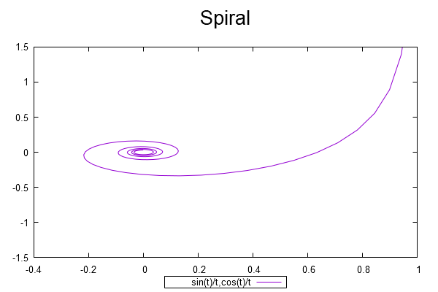

3. Полярная кривая
set output 'polar.png'
set title "Polar"
set polar
set ttics 0,30 format "%g".GPVAL_DEGREE_SIGN font ":Italic"
set mttics 3
set grid r polar 60
unset xtics
unset ytics
set border 0
set size square
unset key
set rrange [0:6.1]
if (GPVAL_ENCODING eq "utf8") {
set ttics add ("π" 180, "π/2" 90, "3π/2" 270)
} else {
set ttics add ("pi" 180, "pi/2" 90, "3pi/2" 270)
}
plot t lt 3 lw 2, -t lt 4 lw 2

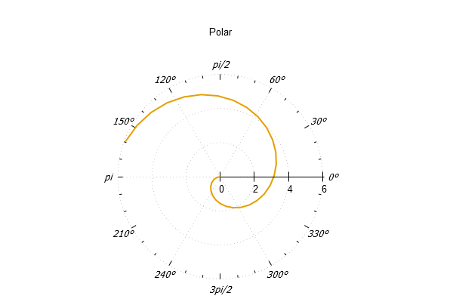
4. Декартовая поверхность
set output 'surface.png'
set title "Surface"
unset log z
set xtics autofreq
set ytics autofreq
set xrange [-1:1]
set yrange [-1:1]
set samples 51
set isosample 21
set dummy u,v
splot u*v / (u**2 + v**2 + 0.1)

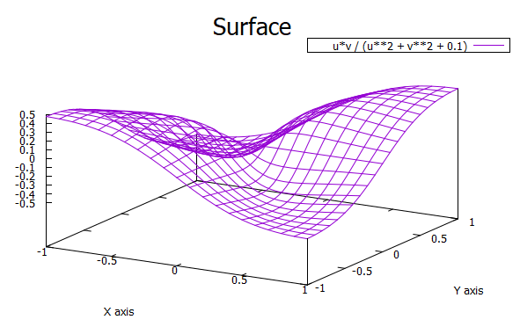

5. Параметрическая поверхность

set output ' Parametric Torus.png'
set title "
Parametric Torus "

set dummy u, v
set key bmargin center horizontal Right noreverse enhanced autotitle nobox
set style increment default
set parametric
set view 45, 50, 1, 1
set isosamples 50, 10
set hidden3d back offset 1 trianglepattern 3 undefined 1 altdiagonal bentover
set style data lines
set ztics norangelimit -1.00000,0.25,1.00000
set urange [ 0.00000 : 6.28319 ] noreverse nowriteback
set vrange [ 0.00000 : 6.28319 ] noreverse nowriteback
set xrange [ * : * ] noreverse writeback
set x2range [ * : * ] noreverse writeback
set yrange [ * : * ] noreverse writeback
set y2range [ * : * ] noreverse writeback
set zrange [ -1.00000 : 1.00000 ] noreverse writeback
set cbrange [ * : * ] noreverse writeback
set rrange [ * : * ] noreverse writeback
splot (1-0.2*cos(v))*cos(u),(1-0.2*cos(v))*sin(u),0.2*sin(v)

