Отчет о лабораторных по курсу Системы трехмерной визуализации студента группы 224 ZИC Кузьмичева Юрия Михайловича.

Декартовые координаты 1 график

set terminal pngcairo size 1200,800
set output "Mega4krivie1.png"
set title "Mega4krivie"
set xlabel "X"
set ylabel "Y"
plot [-pi:pi] sin(x) w line lw 3, cos(x) w impulses, sin(x+1) w boxes, cos(x+1) w lp
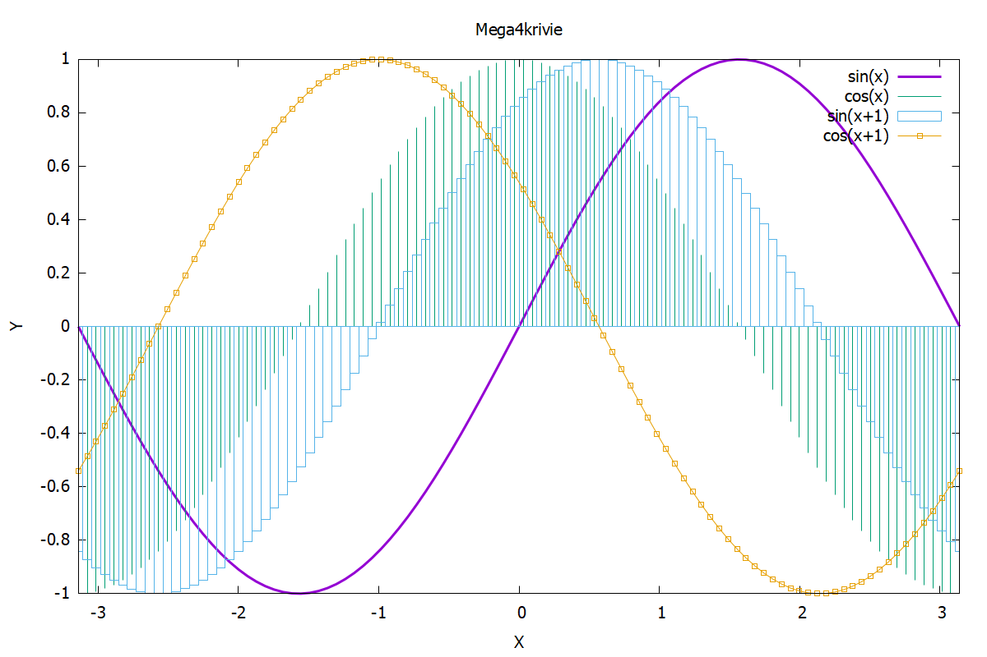

Декартовые координаты 2 график

set terminal pngcairo size 1200,800
set output "Mega4krivie2.png"
set title "Mega Circle"
set size ratio 1
set parametric
plot sin(t),cos(t+2) w boxes,sin(t+2),cos(t) with boxes
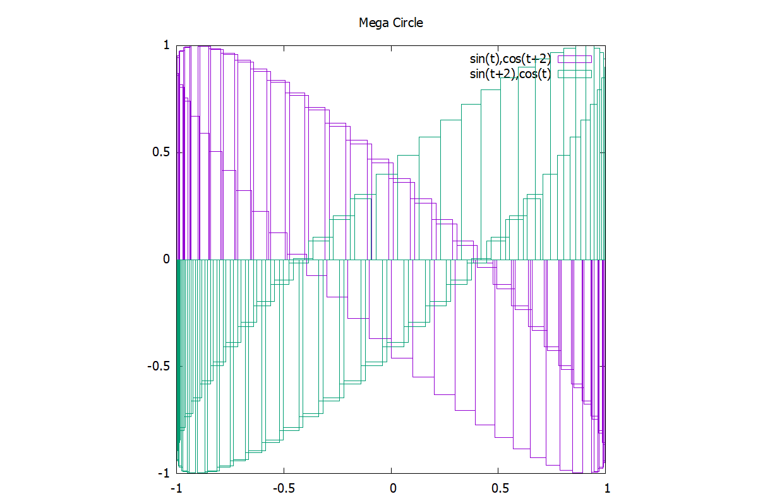

Полярные координаты
set terminal pngcairo size 1200,800
set output "Mega4krivie3.png"
set title "Polar"
set xlabel "X"
set ylabel "Y"
set polar
plot 2-4*sin(t) with impulses lw 2 lt 4, 2-4*sin(t) with lines lw 2
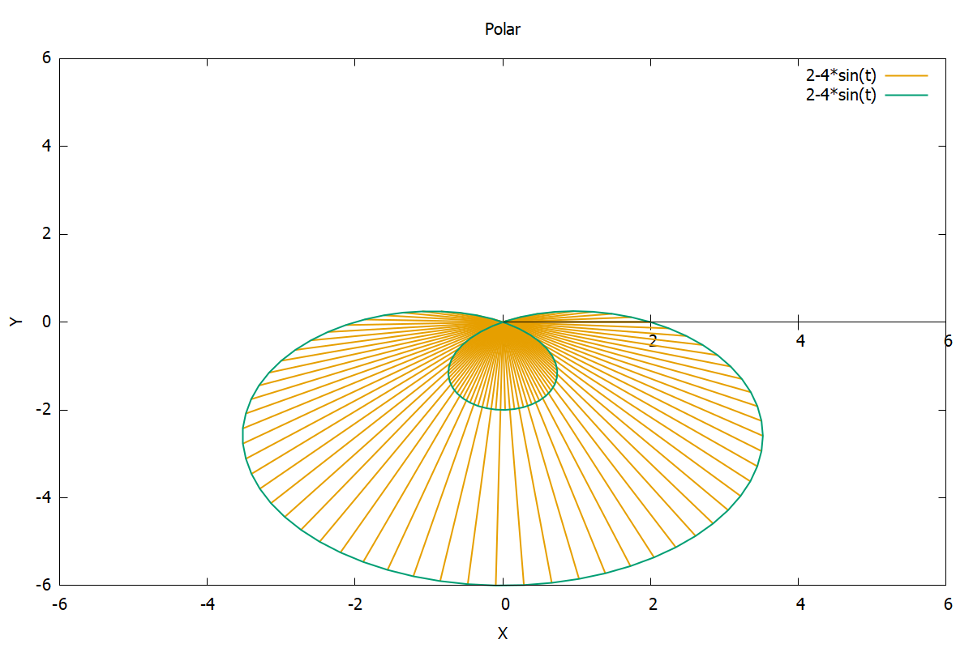

Поверхность 1 график

set terminal pngcairo size 1200,800
set output "Megapoverh2.png"
set title "Mega2krivie"
set xlabel "X"
set ylabel "Y"
set zlabel "Z"
set ztics (50,200,350)
p=2
q=4
splot x**2/2*p+y**2/2*q with lines lw 5,x**2/2*p-y**2/2*q with lines lw 5
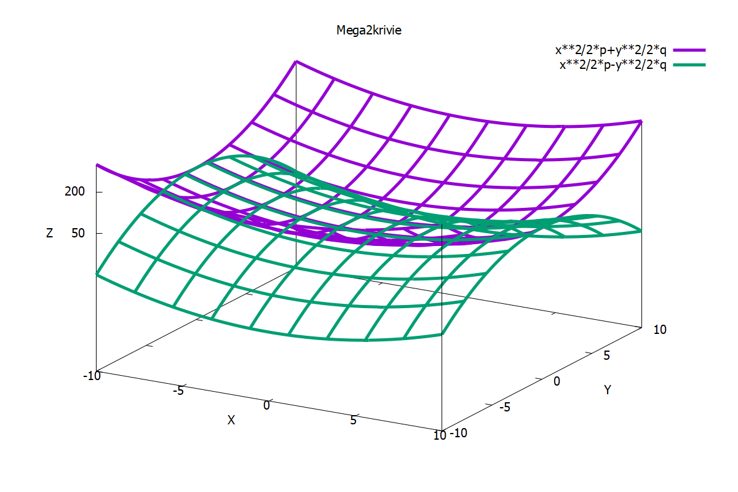

Поверхность 2 график
set terminal pngcairo size 1200,800
set output "Megapoverh2.png"
set mapping spherical
set parametric
set title "Megatube"
set xlabel "X"
set ylabel "Y"
set zlabel "Z"
set xtics(-0.8,-0.6-0.4,-0.2,0,0.2,0.4,-0.6,0.8)
set ytics(-0.8,-0.6-0.4,-0.2,0,0.2,0.4,-0.6,0.8)
set ztics(-0.8,-0.6-0.4,-0.2,0,0.2,0.4,-0.6,0.8)
splot (1-0.1*cos(v))*cos(u),(1-0.1*cos(v))*sin(u),0.1*(sin(v+1)+u/1.7-10)w lines lw 1 lt 6
